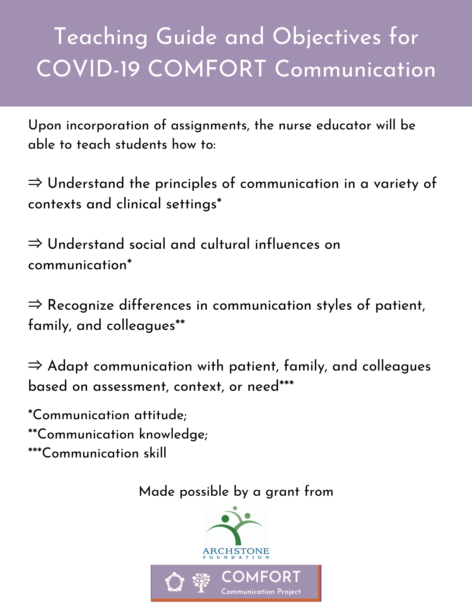
Please visit https://www.communicatecomfort.com/comfort-communication-app for a video overview.
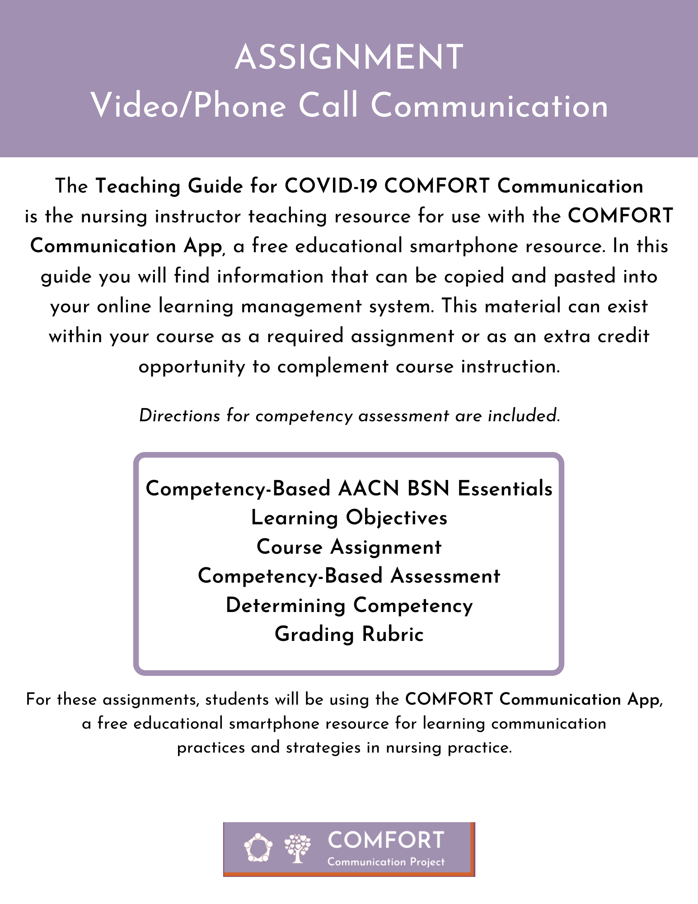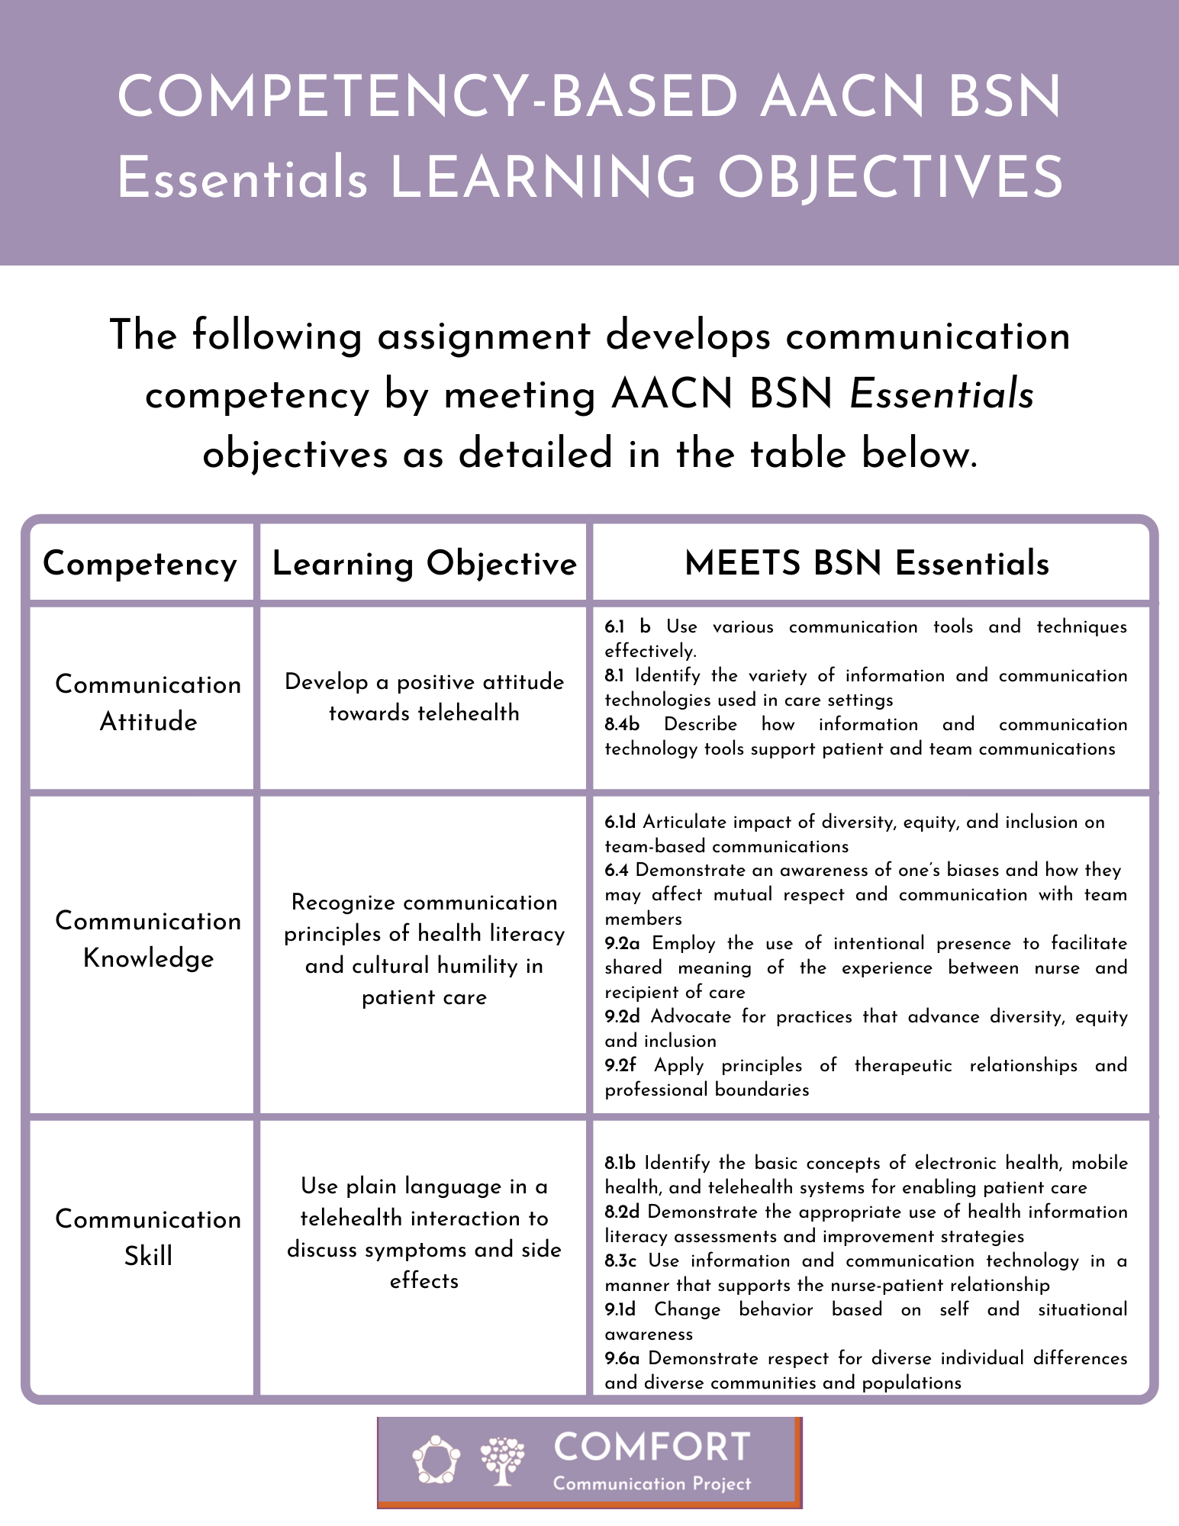Purpose
This assignment is designed to help you understand how to provide patient- and family-centered care during a video or phone call.

Skills
To give examples of their own communication approach for learning about patient/family and to practice providing patient and family education during a video or phone call. The learning outcomes are:
1. Develop a positive attitude towards telehealth
2. Recognize communication principles of health literacy and cultural humility in patient care
3. Use plain language in a telehealth interaction to discuss symptoms and side effects

Tasks
To practice video or phone call communication, complete the following steps:

1. For this assignment, you are required to use the COMFORT Communication App, a free smartphone app that offers communication practices and strategies for nursing practice. You can open a second tab on your computer or use your smartphone device to access: app.communicatecomfort.com.

2. Read the following scenario below and use the App to respond to the questions:

Steafon is recovering from COVID at home. A pediatric oncology nurse for 6 years, Steafon suffered a critical case of COVID. He spent 23 days in the ICU with ventilation and is now in his first week of at-home recovery, still on oxygen and extremely weak. He will receive telemedicine appointments for the next several weeks. Steafon lives with his parents and his sister and her family. In total, eight family members are living together. His mom has been his primary caregiver and will join the video call. She is bilingual, with Spanish as her primary language. The appointment with Steafon today will include a discussion of Steafon’s family/living situation, symptoms and side effects.

a. Use the app (Options: How to Learn More about Your Patient Family) to select two questions you will ask during the appointment and explain why these questions are important to ask.

b. Steafon is short of breath and not able to talk much, so you will need to focus on speaking with his mother about his care. Use the app (COVID: Assessing Patient and Family) to help you assess how Steafon’s mother feels towards the video call appointment. Select two questions you will ask during the appointment and explain why these questions are important to ask.

b. Use the app (Options: Simply Said) to explain the cause of dyspnea and side effects of dexamethasone to Steafon’s mom. Write exactly what you would say to her about both dyspnea and dexamethasone.

c. What may be a communication challenge for you as a first-year nurse when participating in a video/phone call? How could the COMFORT Communication App address those challenges?

