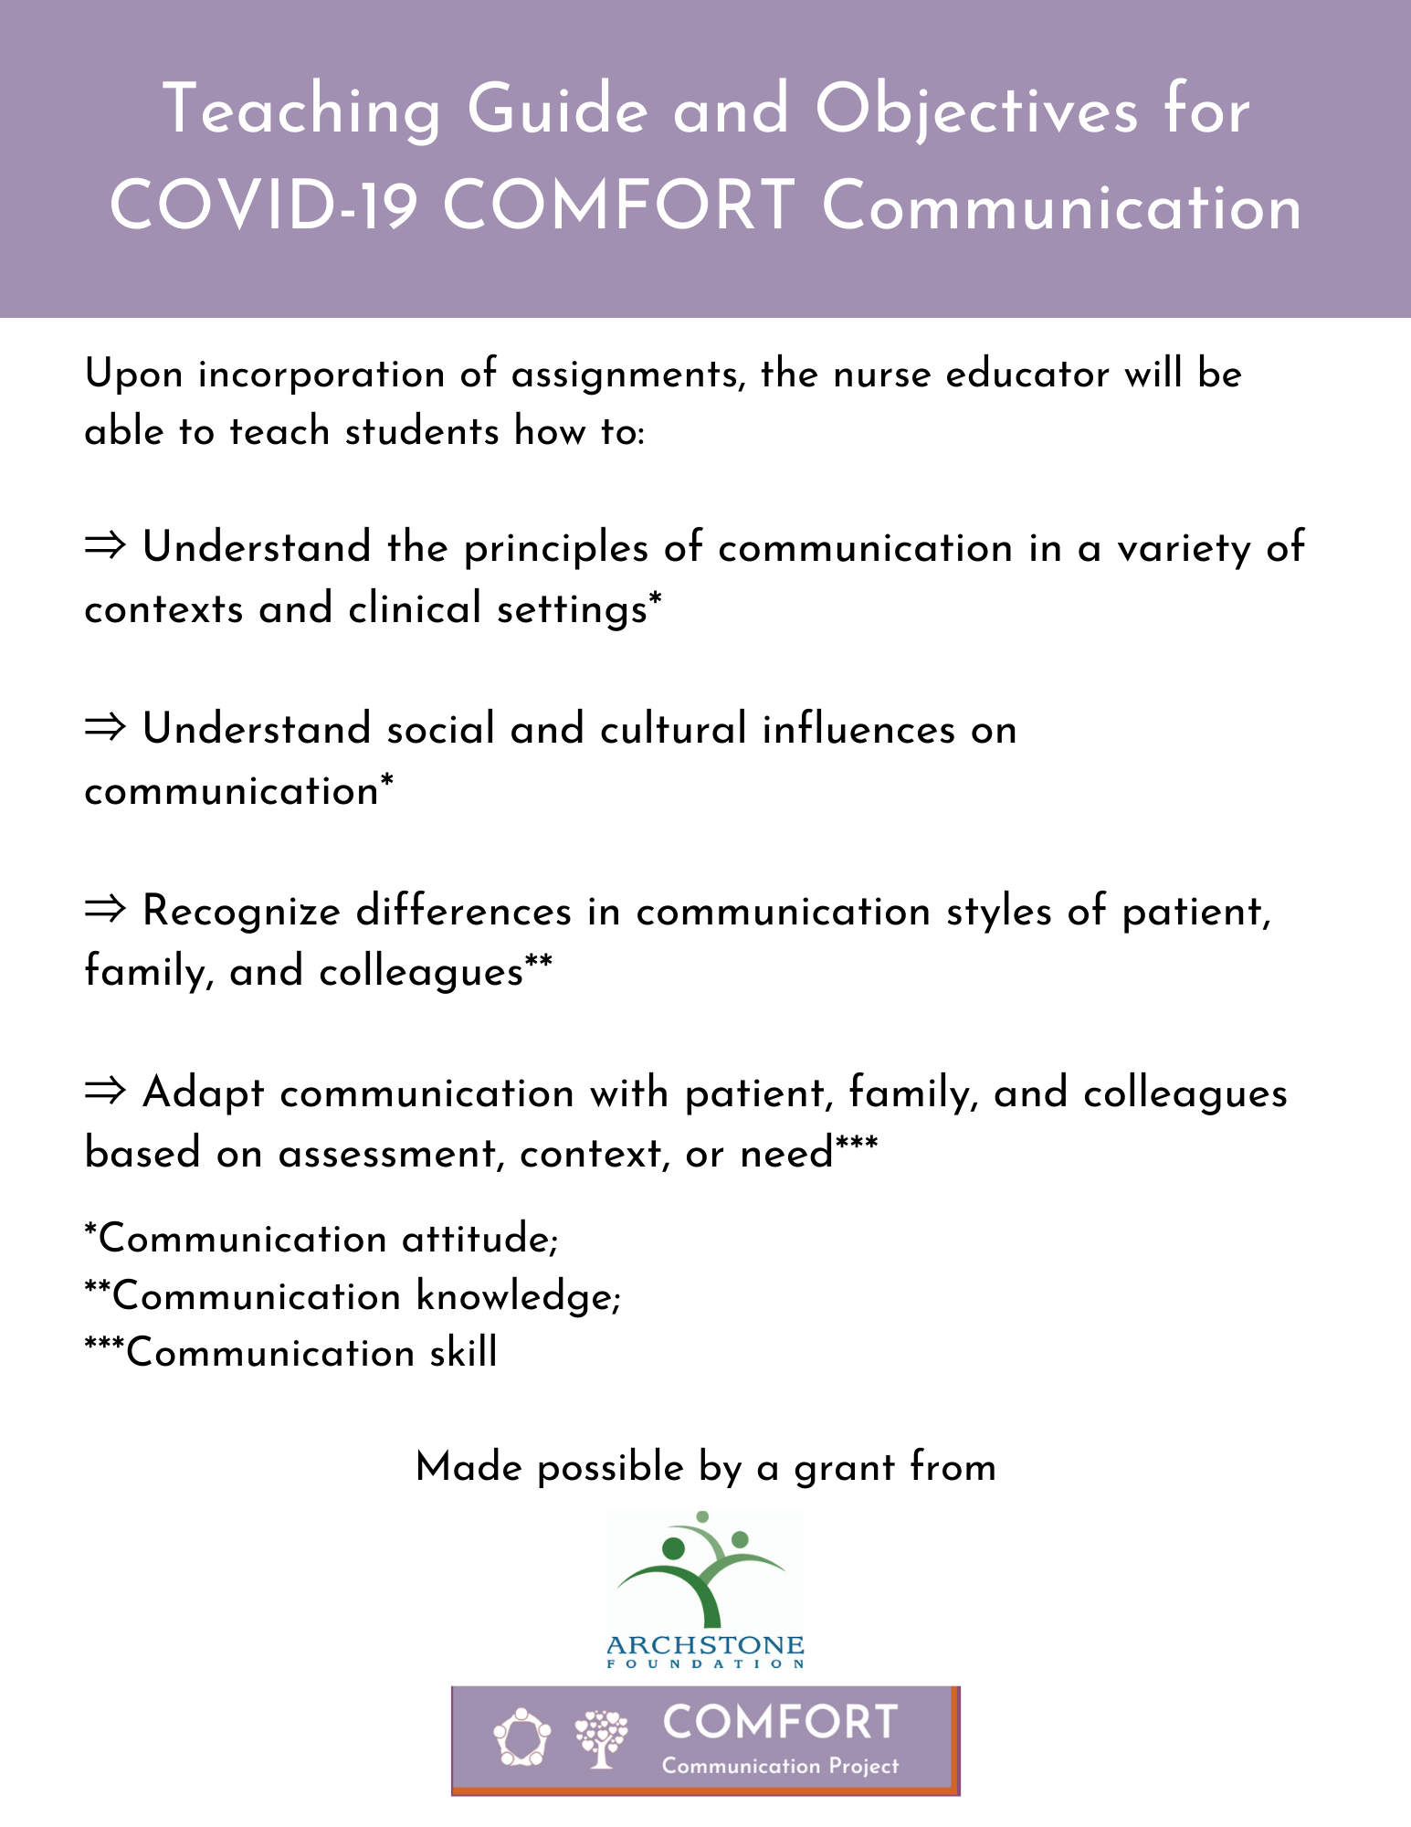 Please visit https://www.communicatecomfort.com/comfort-communication-app for a video overview.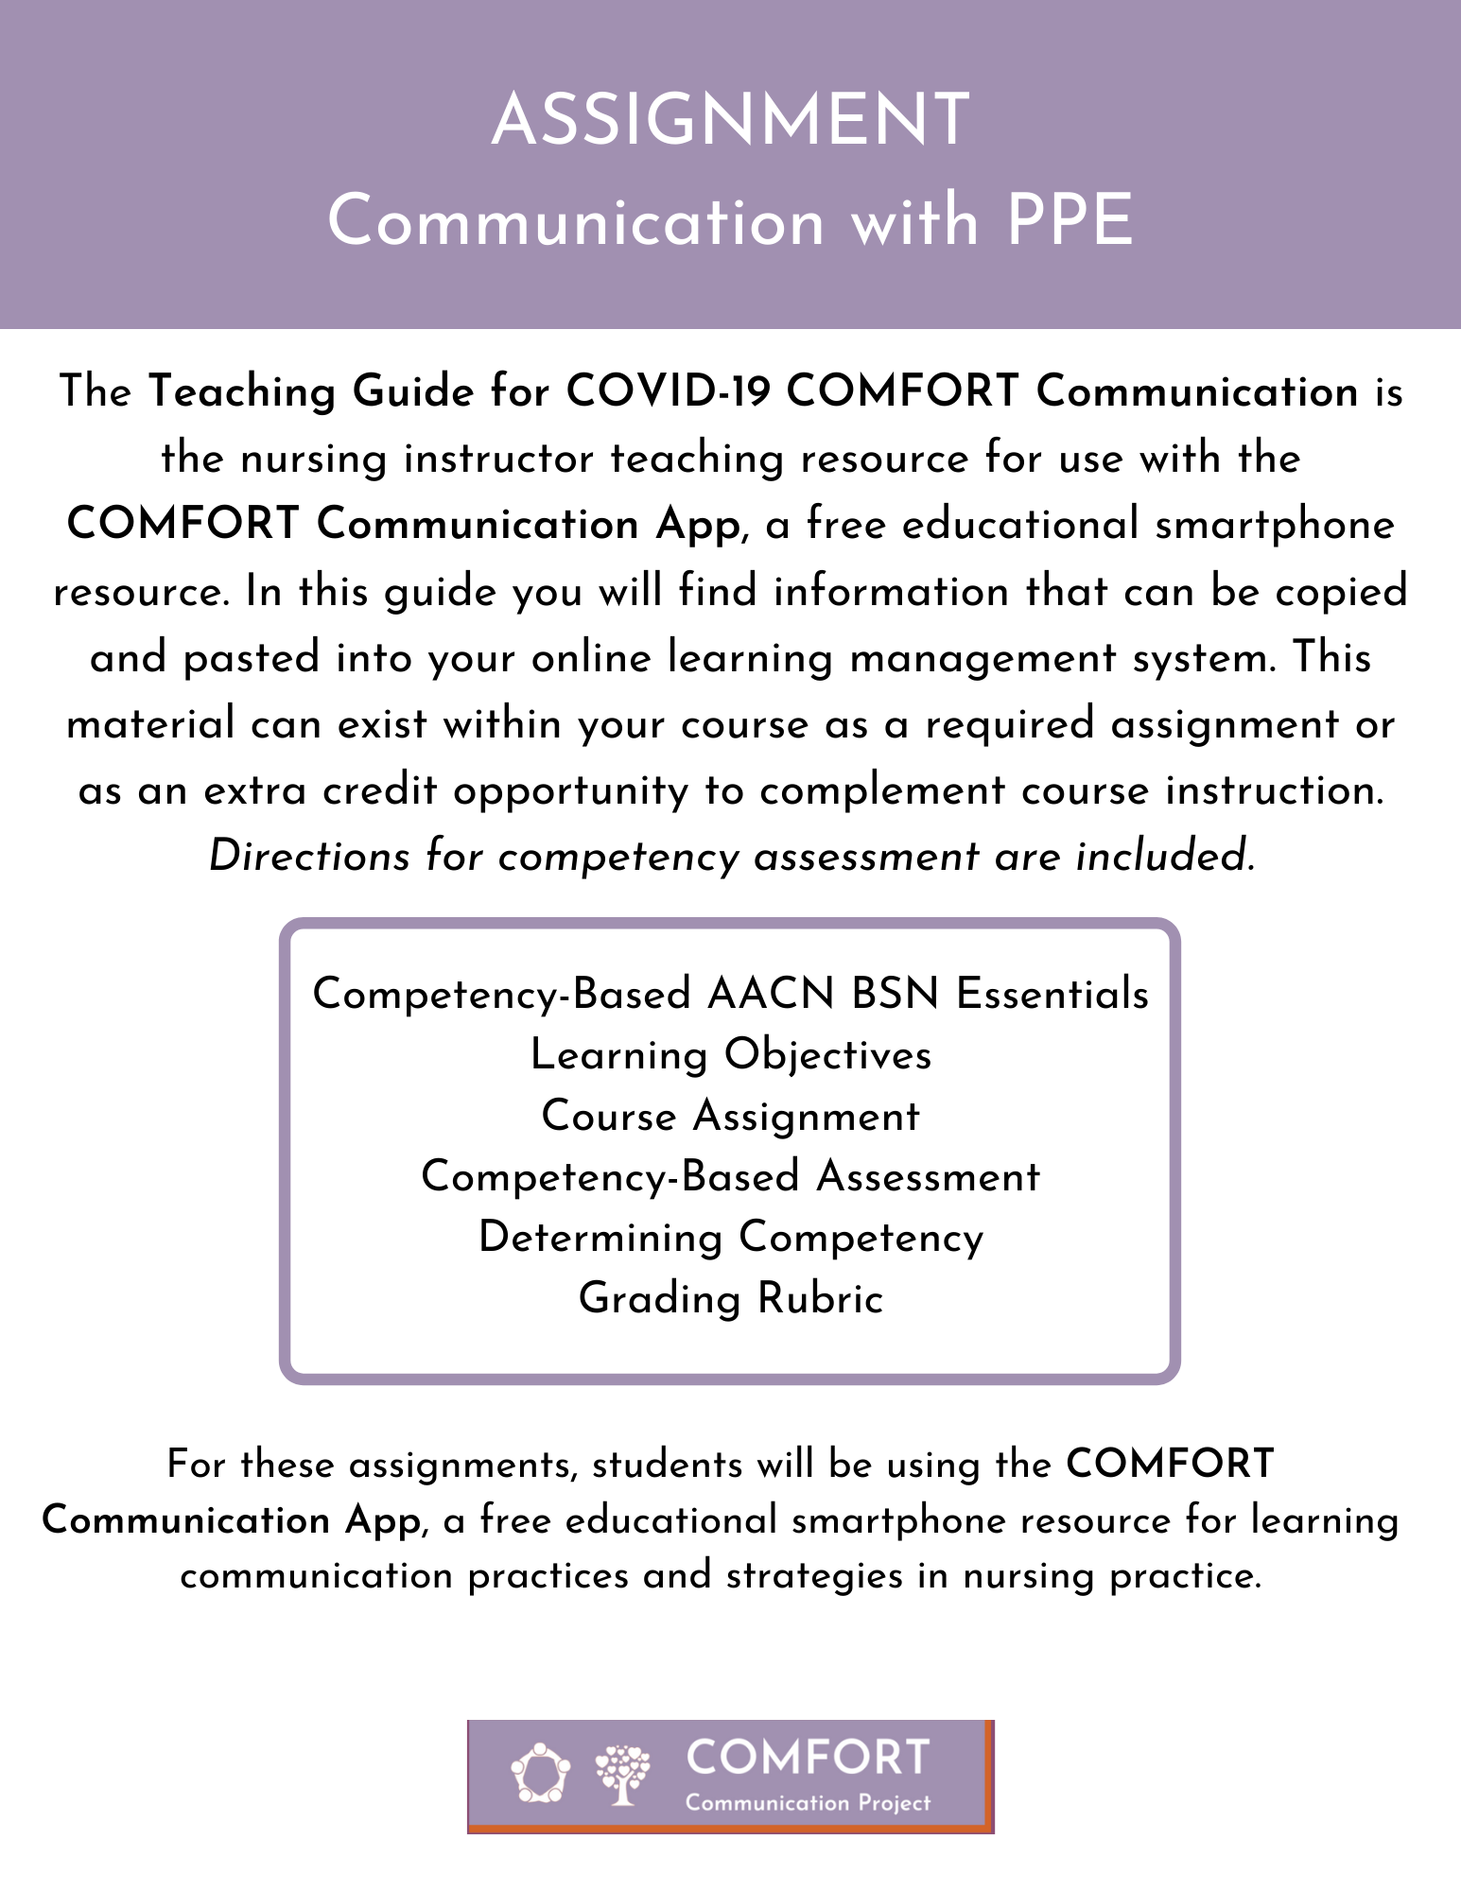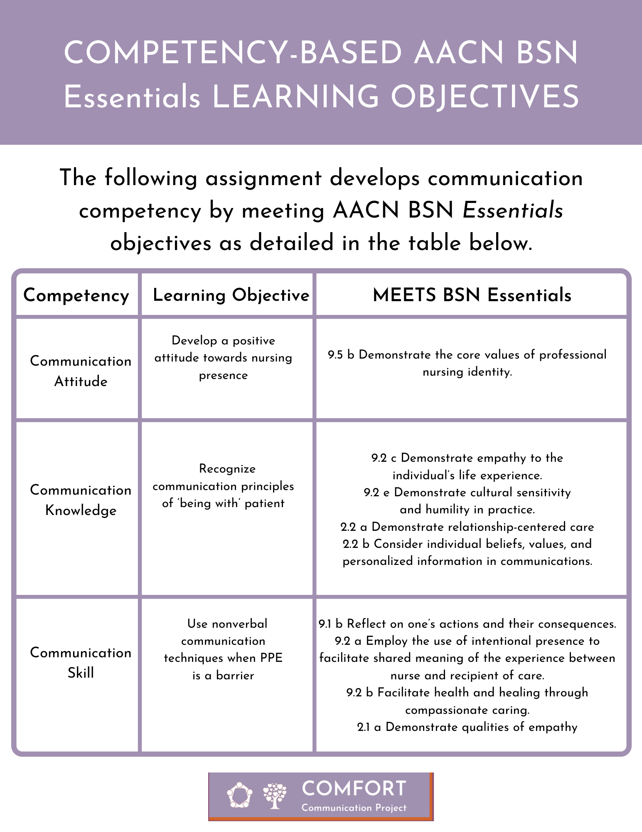
Purpose
This assignment is designed to help you understand how to be present for patient and family when wearing personal protective equipment.

Skills
To give examples of their own communication approach for being with patient/family by using nonverbal communication techniques. The learning outcomes are:
1. Develop a positive attitude towards nursing presence
2. Recognize communication principles of ‘being with’ patient
3. Use nonverbal communication techniques when PPE is a barrier

Tasks
To convey understanding of nonverbal communication techniques, complete the following steps:

1. For this assignment, you are required to use the COMFORT Communication App, a free smartphone app that offers communication practices and strategies for nursing practice. You can open a second tab on your computer or use your smartphone device to access: app.communicatecomfort.com

2. Read the following scenario below and use the App to respond to the questions:

Alvin is 68, facing his third day in the COVID unit of the hospital and receiving oxygen. Manuel, his nurse, is seeing Alvin for the first time. Manuel is wearing a full sleeve gown, hair covering, N95 mask, face shield, and double gloves. In addition to COVID-19, Alvin has been living with Type-2 Diabetes for nearly twenty years and has advanced retinopathy. Seeing the already obscured faces and eyes of his care team members is now made much more difficult in light of the PPE required. Manuel needs to share news with Alvin about his status and the treatment he is receiving.

a. Use the app (COVID: Reconnect through PPE) and describe how Manuel can convey caring/presence with Alvin despite PPE communication barriers. Explain why this is important.
b. After hearing that his partner cannot visit during his hospitalization due to the pandemic, tears travel down both of Alvin’s cheeks. Use the Making Meaning: Being Present for the Patient and Family section of the app to identify a communication strategy/approach and explain how Manuel can use this strategy/approach to be present for Alvin.
Identify two nonverbal communication behaviors (Connect: Nonverbal Communication section of the app) that could be used to improve Manuel’s care for Alvin. Explain how each nonverbal behavior could be used by Manuel to convey care and compassion for Alvin.

